**DATA STRUCTURES LAB-PROGRAMS**

VARSHA.S

1BM19CS179

'3D'- Batch-1

**LAB -1**

**Write a program to simulate the working of stack using an array with the following :**

**a) Push b) Pop c) Display**

#include <stdio.h>

#define SIZE 5

int top=-1;

int stack[SIZE];

void push(int ele)

{

if(isFull())

{

printf("The stack is full\n");

}

else

{

top++;

stack[top]=ele;

}

}

int pop()

{

if(isEmpty())

{

return 0;

}

else

{

return stack[top--];

}

}

int isEmpty()

{

if(top==-1)

return 1;

else

return 0;

}

int isFull()

{

if(top==SIZE-1)

return 1;

else

return 0;

}

void display()

{

if(isEmpty())

printf("The stack is empty\n");

else

{

printf("The elements are\n");

for(int i=0;i<=top;i++)

{

printf("%d\n",stack[i]);

}

}

}

int main()

{

int c,d,p;

while(1)

{

printf("Enter command\n1-push\n2-pop\n3-Display\n");

scanf("%d",&c);

switch(c)

{

case 1:printf("Enter an element\n");

scanf("%d",&d);

push(d);

break;

case 2:p=pop();

if(p==0)

printf("Stack is empty\n");

else

printf("Element removed succesfully\n");

break;

case 3:display();

break;

case 4:exit(0);

default: printf("Invalid input\n");

}

}

return 0;

}

**OUTPUT:**

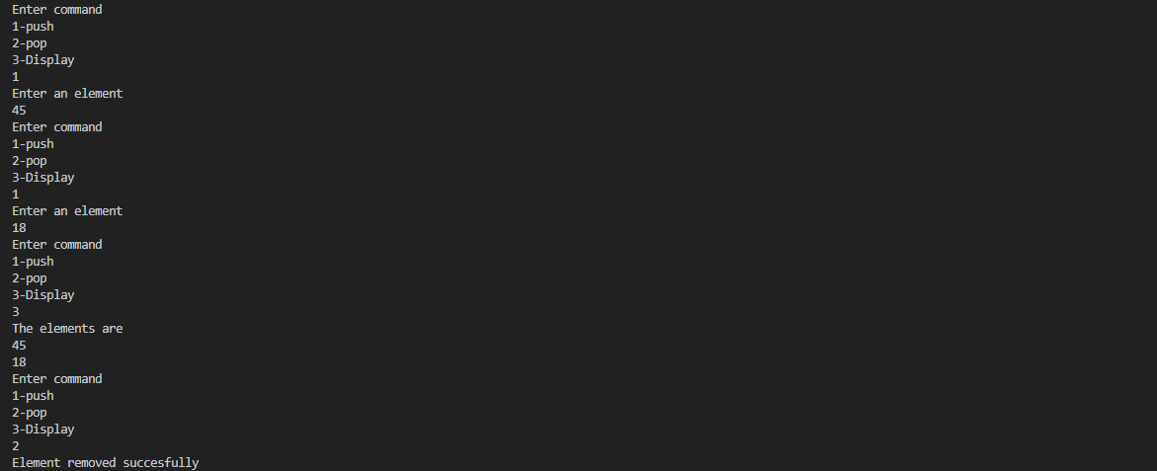

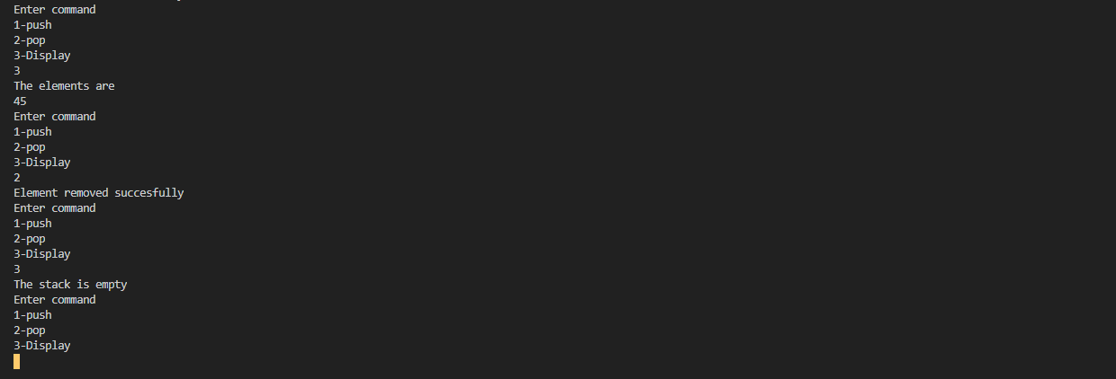

**LAB-2**

**WAP to convert a given valid parenthesized infix arithmetic expression to postfix**

**expression. The expression consists of single character operands and the binary operators**

**+ (plus), - (minus), * (multiply) and / (divide)**

#include<stdio.h>

#include<ctype.h>

#define SIZE 50

char stack[SIZE];

int top=-1;

push(char elem)

{

stack[++top]=elem;

}

char pop()

{

return(stack[top--]);

}

int pr(char symbol)

{

if(symbol== '^')

{

return(3);

}

else if(symbol== '*' || symbol== '/' )

{

return(2);

}

else if(symbol== '+' || symbol== '-')

{

return(1);

}

else {

return(0);

}

}

void main()

{

char infix[50],postfix[50],ch,elem;

int i=0,k=0;

printf("enter Infix expression");

scanf("%s",infix);

push('#');

while((ch=infix[i++])!='\0' )

{

if(ch == '(') push(ch);

else

if(isalnum(ch)) postfix[k++]=ch;

else

if(ch==')')

{ while(stack[top] !='(')

postfix[k++]=pop();

elem=pop();

}

else

{

while(pr(stack[top]) >=pr(ch))

postfix[k++]=pop();

push(ch);

}

}

while(stack[top]!='#')

postfix[k++]=pop();

postfix[k]='\0';

printf("\nPostfixexpression=%s\n",postfix);

}

**OUTPUT:**



**LAB-3**

**WAP to simulate the working of a queue of integers using an array. Provide the following**

**operations**

**a) Insert b) Delete c) Display**

#include <stdio.h>

#define MAX 10

void insert();

void delete();

void display();

int queue_array[MAX];

int rear = - 1;

int front = - 1;

main()

{

int choice;

while (1)

{

printf("1.Insert element to queue \n");

printf("2.Delete element from queue \n");

printf("3.Display all elements of queue \n");

printf("4.Quit \n");

printf("Enter your choice : ");

scanf("%d", &choice);

switch (choice)

{

case 1:

insert();

break;

case 2:

delete();

break;

case 3:

display();

break;

case 4:

exit(1);

default:

printf("Wrong choice \n");

}

}

}

void insert()

{

int add_item;

if (rear == MAX - 1)

printf("Queue Overflow \n");

else

{

if (front == - 1)

front = 0;

printf("Inset the element in queue : ");

scanf("%d", &add_item);

rear = rear + 1;

queue_array[rear] = add_item;

}

}

void delete()

{

if (front == - 1 || front > rear)

{

printf("Queue Underflow \n");

return ;

}

else

{

printf("Element deleted from queue is : %d\n", queue_array[front]);

front = front + 1;

}

}

void display()

{

int i;

if (front == - 1)

printf("Queue is empty \n");

else

{

printf("Queue is : \n");

for (i = front; i <= rear; i++)

printf("%d ", queue_array[i]);

printf("\n");

}

}

**OUTPUT:**

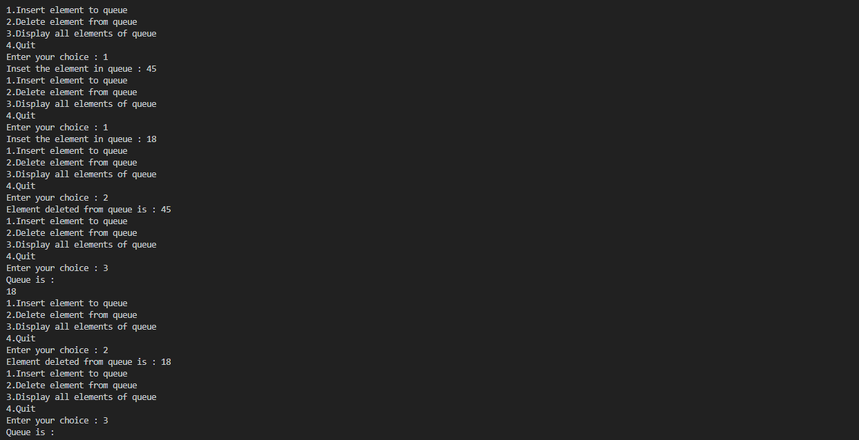

**LAB-4**

**WAP to simulate the working of a circular queue of integers using an array. Provide the**

**following operations.**

**a) Insert b) Delete c) Display**

#include <stdio.h>

#include <stdlib.h>

#define SIZE 6

int a[SIZE],t;

int front=-1;

int rear=-1;

int IsEmpty()

{

if(rear==-1 && front==-1)

return 1;

else

return 0;

}

int IsFull()

{

if(front==(rear+1)%SIZE)

return 1;

else

return 0;

}

void Enqueue(int x)

{

if(IsFull())

printf("The queue is full\n");

else if(IsEmpty())

{

front=0;

rear=0;

a[rear]=x;

}

else

{

rear=(rear+1)%SIZE;

a[rear]=x;

}

}

int Dequeue()

{ int x;

if(IsEmpty())

printf("The queue is empty.\n");

else if(front==rear)

{

x=a[front];

front=-1;

rear=-1;

printf("The element was removed\n");

}

else

{

x=a[front];

front=(front+1)%SIZE;

printf("The element was removed\n");

}

return x;

}

void display()

{

if (front == -1)

{

printf("\nQueue is Empty");

return;

}

printf("\nElements in Circular Queue are:\n");

if (rear >= front)

{

for (int i = front; i <= rear; i++)

printf("%d\n",a[i]);

}

else

{

for (int i = front; i < SIZE; i++)

printf("%d\n", a[i]);

for (int i = 0; i <= rear; i++)

printf("%d\n", a[i]);

}

}

int main()

{

int n,a;

while(1)

{

printf("Enter the operation.\n1-Insert\n2-Delete\n3-Display\n4-Exit\n");

scanf("%d",&n);

switch(n)

{

case 1: printf("Enter the element\n");

scanf("%d",&a);

Enqueue(a);

break;

case 2 : Dequeue();

break;

case 3: display();

break;

case 4: exit(0);

default : printf("There is no such operation\n");

}

}

return 0;

}

**OUTPUT:**



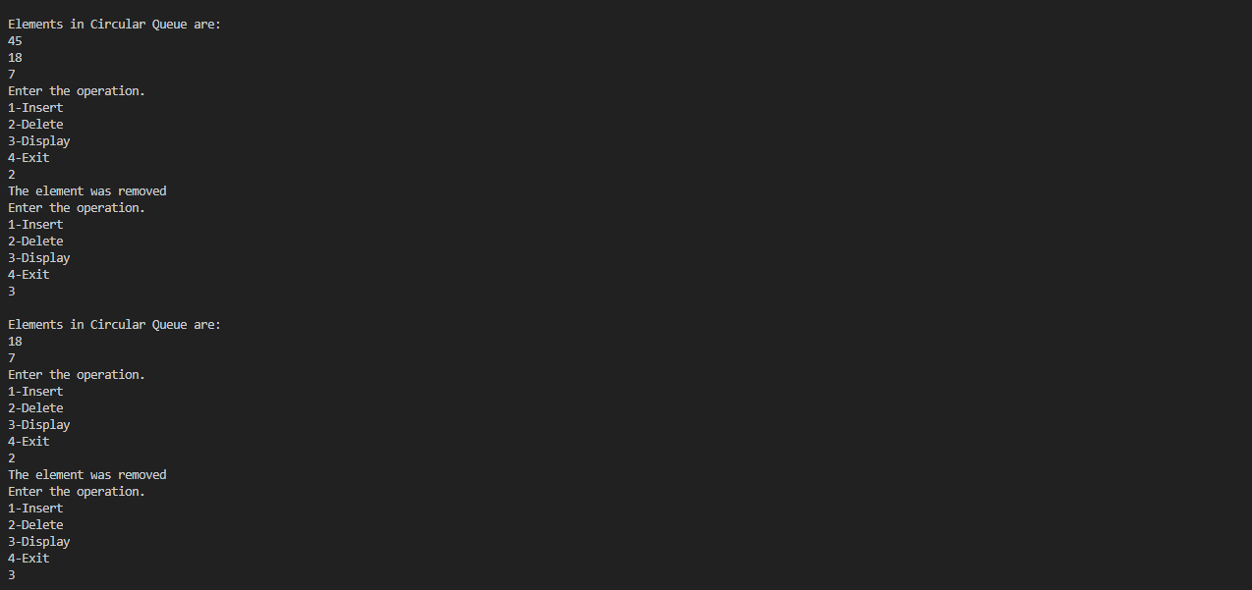

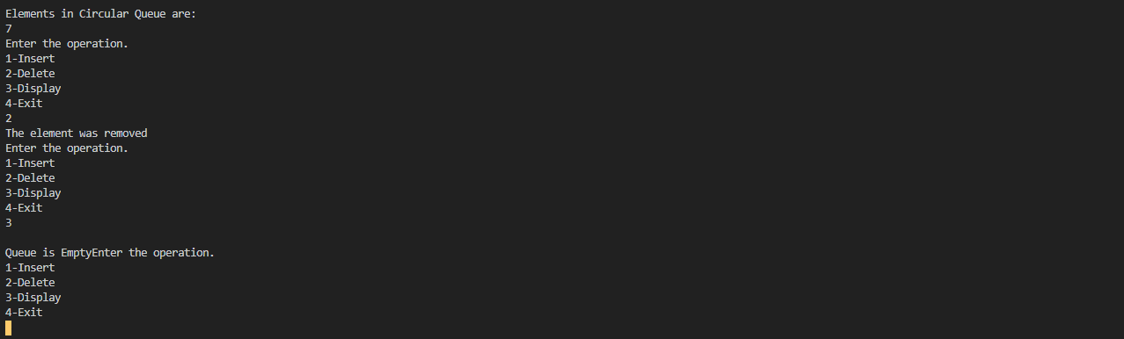

**LAB-5 & LAB-6**

**WAP to Implement Singly Linked List with following operations**

**a) a) Create a linked list. b) Insertion of a node at first position, at any position and at end of**

**list. c) Display the contents of the linked list**

**WAP to Implement Singly Linked List with following operations**

**a) a) Create a linked list. b) Deletion of first element, specified element and last element in**

**the list. c) Display the contents of the linked list.**

#include <stdio.h>

#include <stdlib.h>

typedef struct node{

int data;

struct node *link;

}node;

node *root=NULL;

void add_at_end()

{

node *temp;

temp=(node *)malloc(sizeof(node));

printf("Enter the node element\n");

scanf("%d",&temp->data);

temp->link=NULL;

if(root==NULL)

{

root=temp;

}

else

{

node *p=root;

while(p->link!=NULL)

{

p=p->link;

}

p->link=temp;

}

}

void add_at_begin()

{

node *temp;

temp=(node *)malloc(sizeof(node));

printf("Enter node element\n");

scanf("%d",&temp->data);

temp->link=NULL;

if(root==NULL)

{

root=temp;

}

else

{

temp->link=root;

root=temp;

}

}

int length()

{

node *p;

p=root;

int i=0;

while(p!=NULL)

{

i++;

p=p->link;

}

return i;

}

void add_after(){

node *p,*temp;

int loc,i=1;

printf("Enter the location");

scanf("%d",&loc);

if(loc>length())

{

printf("Invalid location. The list has %d nodes",length());

}

else

{

p=root;

while(i<loc)

{

p=p->link;

i++;

}

temp=(node *)malloc(sizeof(node));

printf("Enter the node element\n");

scanf("%d",&temp->data);

temp->link=NULL;

temp->link=p->link;

p->link=temp;

}

}

void delete()

{

int loc;

node *temp;

printf("Enter the locatin of node to be deleted\n");

scanf("%d",&loc);

if (loc>length())

{

printf("There is no such node\n");

}

else if (loc==1)

{

temp=root;

root=temp->link;

temp->link=NULL;

free(temp);

}

else

{

node *p=root,*q;

int i=1;

while(i<loc-1)

{

p=p->link;

i++;

}

q=p->link;

p->link=q->link;

q->link=NULL;

free(q);

}

}

void display()

{

node *temp=root;

if(temp==NULL)

{

printf("No nodes in the list\n");

}

else

{

while(temp!=NULL)

{

printf("%d\n",temp->data);

temp=temp->link;

}

}

}

int main()

{

int op,len;

while(1)

{ printf("Enter the operation\n1.Add in begin\n2.Add at end\n");

printf("3.Add after a node\n4.Delete node\n5.Display\n6.Length of list\n7.Exit\n");

scanf("%d",&op);

switch (op)

{

case 1:add_at_begin();

break;

case 2: add_at_end();

break;

case 3: add_after();

break;

case 4: delete();

break;

case 5: display();

break;

case 6: len=length();

printf("The length is %d\n",len);

break;

case 7: exit(0);

break;

default: printf("No such operation\n");

}

}

return 0;

}

**OUTPUT:**

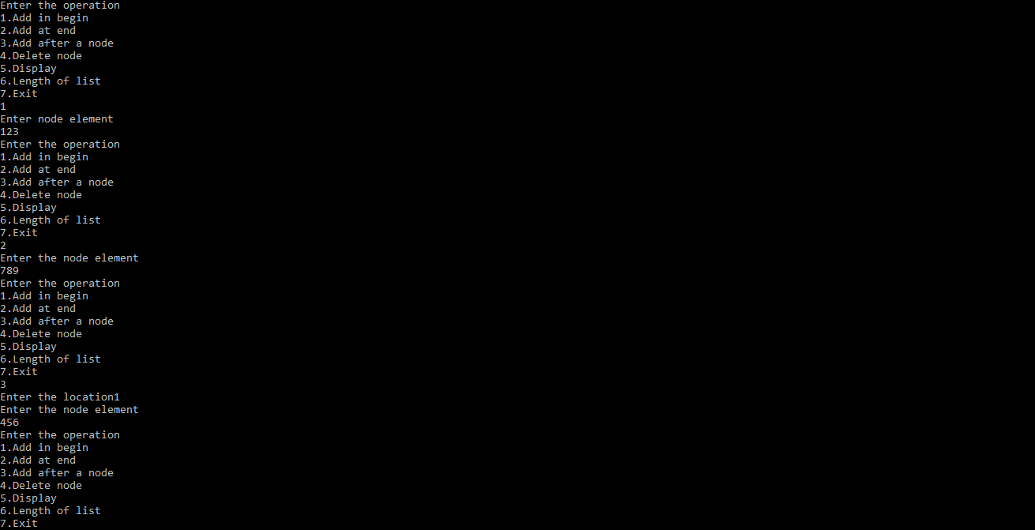

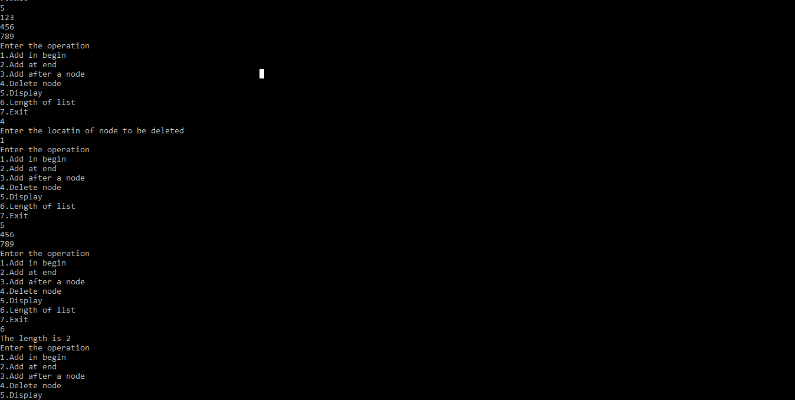

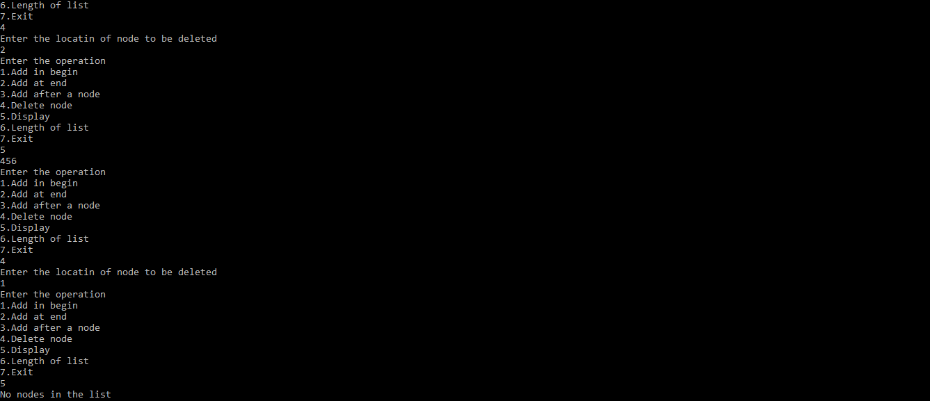

**LAB-7**

**WAP Implement Single Link List with following operations**

**a) a) Sort the linked list. b) Reverse the linked list. c) Concatenation of two linked lists.**

**sort and reverse:**

#include <stdio.h>

#include <stdlib.h>

void count();

void putBeg(int value);

void put(int pos, int value);

void putEnd(int value);

void delFirst();

void delLast();

void delPos();

void display();

void inputValue(int *add);

void inputPos(int *add);

void reverse();

void sort();

typedef struct node {

int value;

struct node* next;

}node;

void swap(node*, node*);

node* head = NULL;

void putBeg(int value)

{

node* ptr = (node*) malloc((sizeof(node)));

ptr -> value = value;

ptr->next = head;

head = ptr;

}

void put(int pos, int value)

{

if(pos==0)

{

putBeg(value);

return;

}

int i = 0;

node* tmp = head;

while(i != pos-1 && tmp != NULL)

{

i++;

tmp = tmp->next;

}

if(i != pos-1 || tmp == NULL)

{

printf("\n\nERROR\nEnter Correct Index\n\n");

return;

}

node* ptr = (node*) malloc((sizeof(node)));

ptr -> value = value;

ptr->next = (tmp->next);

tmp->next = ptr;

}

void putEnd(int value) {

node* ptr = (node*) malloc((sizeof(node)));

ptr -> value = value;

ptr->next=NULL;

if(head==NULL)

{

head=ptr;

return;

}

node* tmp = head;

for(;tmp->next!=NULL;tmp=tmp->next);

tmp->next=ptr;

}

void display() {

if(head==NULL){

printf("\n\nLinked List is Empty\n\n");

return;

}

printf("\n\nLinked List Contains : ");

for(node* tmp=head;tmp!=NULL;tmp = tmp->next)

printf("%d ", tmp->value);

printf("\n\n");

}

void delFirst() {

if(head==NULL){

printf("\n\nLinked List is Empty\n\n");

return;

}

node *tmp = head->next;

free(head);

head = tmp;

}

void delLast() {

if(head==NULL){

printf("\n\nLinked List is Empty\n\n");

return;

}

if(head->next == NULL)

{

free(head);

head=NULL;

return;

}

node* tmp = head;

for(;(tmp->next)->next!=NULL;tmp=tmp->next);

free(tmp->next);

tmp->next = NULL;

}

void delPos(int pos){

if(head==NULL){

printf("\n\nLinked List is Empty\n\n");

return;

}

if(pos==0)

{

delFirst();

return;

}

int i = 0;

node* tmp = head;

while(i!=pos-1&&tmp!=NULL)

{

i++;

tmp = tmp->next;

}

if(i!=pos-1||tmp->next==NULL)

{

printf("\n\nERROR\nEnter Correct Index\n\n");

return;

}

node* tmp1 = tmp->next;

tmp->next = (tmp->next)->next;

free(tmp1);

}

void reverse() {

if(head == NULL) {

printf("\n\nLinked List is empty\n\n");

return;

}

if(head -> next == NULL){

printf("\n\nReversed\n\n");

return;

}

node* tmp;

node* current = head -> next;

node* previous = head;

while(current != NULL) {

tmp = current->next;

current -> next = previous;

previous = current;

current = tmp;

}

head->next=NULL;

head = previous;

printf("\n\nReversed\n\n");

return;

}

void sort()

{

int flag, i;

node *ptr1;

node *ptr2 = NULL;

if (head == NULL)

return;

do

{

flag = 0;

ptr1 = head;

while (ptr1->next != ptr2)

{

if (ptr1->value > ptr1->next->value)

{

swap(ptr1, ptr1->next);

flag = 1;

}

ptr1 = ptr1->next;

}

ptr2 = ptr1;

}

while (flag);

printf("\n\nSorted\n\n");

}

void swap(node *a, node *b)

{

int temp = a->value;

a->value = b->value;

b->value = temp;

}

void inputValue(int *add)

{

printf("Enter element to be added : ");

scanf("%d", add);

}

void inputPos(int* add){

printf("Enter index : ");

scanf("%d", add);

}

void main() {

int choice = 0, input, pos;

while(1)

{

count();

printf("Enter 1 to add at beginning\n");

printf("Enter 2 to add at end\n");

printf("Enter 3 to add at given index\n");

printf("Enter 4 to delete first element\n");

printf("Enter 5 to delete last element\n");

printf("Enter 6 to delete element at given index\n");

printf("Enter 7 to display\n");

printf("Enter 8 to reverse\n");

printf("Enter 9 to sort\n");

printf("Enter -1 to quit\n");

printf("Enter your choice : ");

scanf("%d", &choice);

if(choice==-1)

break;

switch(choice)

{

case 1:

inputValue(&input);

putBeg(input);

break;

case 2:

inputValue(&input);

putEnd(input);

break;

case 3:

inputValue(&input);

inputPos(&pos);

put(pos, input);

break;

case 4:

delFirst();

break;

case 5:

delLast();

break;

case 6:

inputPos(&pos);

delPos(pos);

break;

case 7:

display();

break;

case 8:

reverse();

break;

case 9:

sort();

break;

default:

printf("\n\nIncorrect Choice\n\n");

break;

}

}

printf("\n\n-----DONE-----\n\n");

}

void count() {

int i = 0;

node* tmp=head;

while(tmp!=NULL) {

i++;

tmp = tmp->next;

}

printf("\n\nCount : %d\n\n", i);

}

**OUTPUT:**

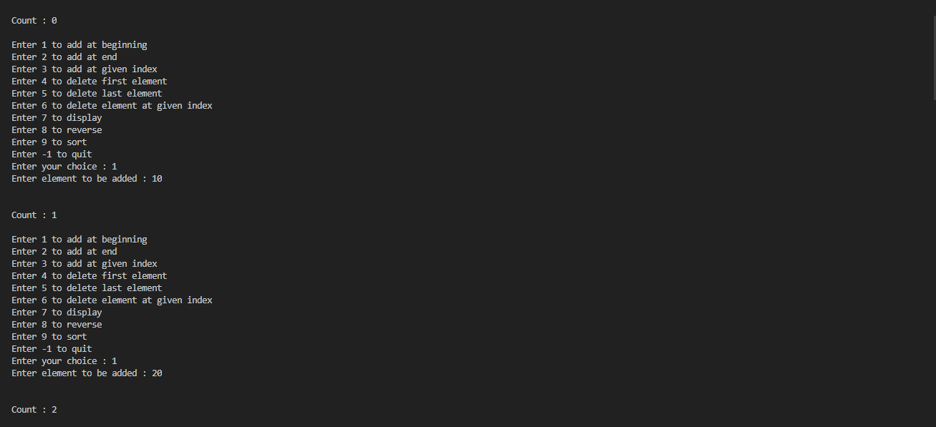

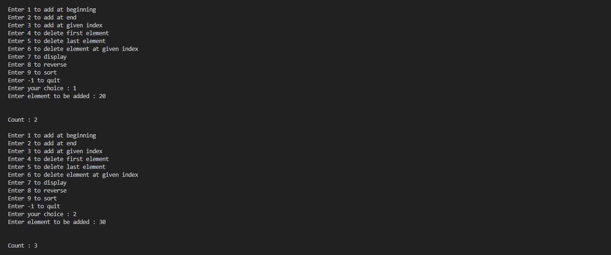

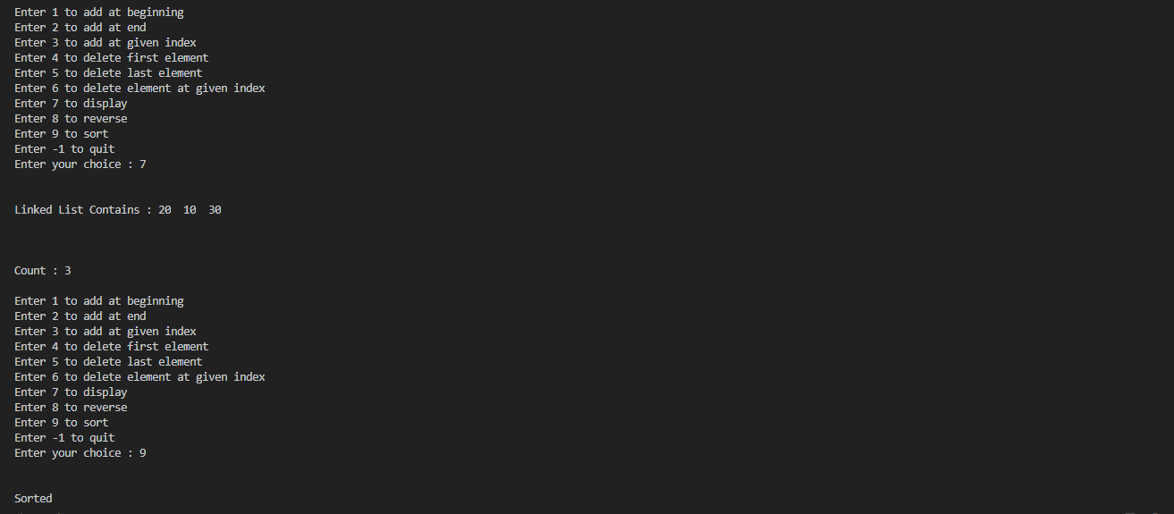

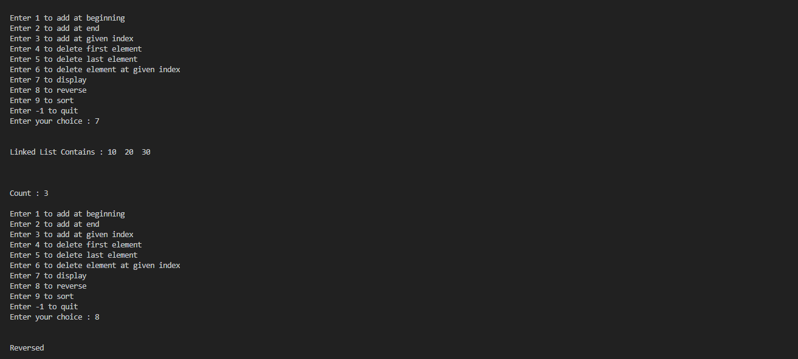

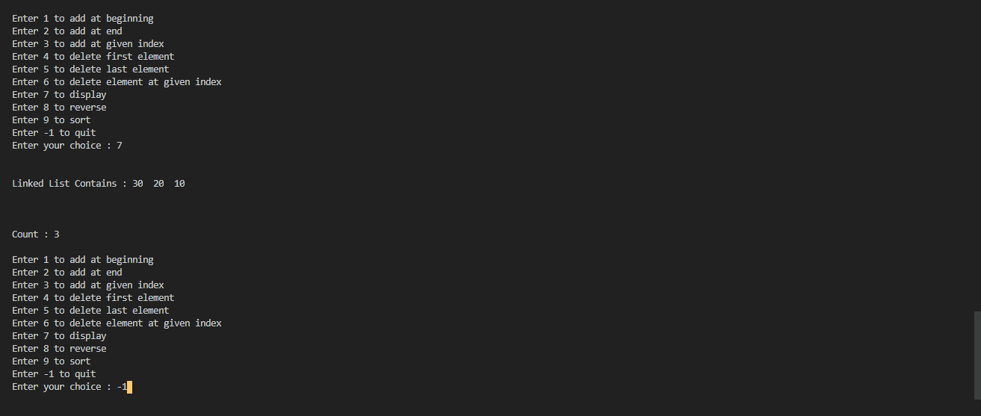

**merge , contatenate:**

#include <stdio.h>

#include <stdlib.h>

typedef struct node {

int value;

struct node* next;

}node;

void swap(node*, node*);

void add_beg(int, node**);

node* head3 = NULL;

node* head1 = NULL;

node* head2 = NULL;

node* head4 = NULL;

void del_beg(node** head) {

if(*head==NULL){

printf("\n\nLinked List is Empty\n\n");

return;

}

node *tmp = (*head)->next;

free(*head);

*head = tmp;

}

void del_end(node** head) {

if(*head==NULL){

printf("\n\nLinked List is Empty\n\n");

return;

}

if((*head)->next == NULL)

{

free(*head);

*head=NULL;

return;

}

node* tmp = *head;

for(;(tmp->next)->next!=NULL;tmp=tmp->next);

free(tmp->next);

tmp->next = NULL;

}

void add_end(int value, node** head) {

node* ptr = (node*) malloc(sizeof(node));

ptr -> value = value;

ptr->next=NULL;

if(*head == NULL) {

*head = ptr;

return;

}

node* tmp = *head;

while(tmp->next!=NULL) {

tmp = tmp -> next;

}

tmp -> next = ptr;

}

void del_pos(int pos, node** head){

if(*head==NULL){

printf("\n\nLinked List is Empty\n\n");

return;

}

if(pos==0)

{

del_beg(head);

return;

}

int i = 0;

node* tmp = *head;

while(i!=pos-1&&tmp!=NULL)

{

i++;

tmp = tmp->next;

}

if(i!=pos-1||tmp->next==NULL)

{

printf("\n\nERROR\nEnter Correct Index\n\n");

return;

}

node* tmp1 = tmp->next;

tmp->next = (tmp->next)->next;

free(tmp1);

}

void add_pos(int pos, int value, node** head)

{

if(pos==0)

{

add_beg(value, head);

return;

}

int i = 0;

node* tmp = *head;

while(i != pos-1 && tmp != NULL)

{

i++;

tmp = tmp->next;

}

if(i != pos-1 || tmp == NULL)

{

printf("\n\nERROR\nEnter Correct Index\n\n");

return;

}

node* ptr = (node*) malloc((sizeof(node)));

ptr -> value = value;

ptr->next = (tmp->next);

tmp->next = ptr;

}

void add_beg(int value, node** head) {

node* ptr = (node*) malloc(sizeof(node));

ptr -> value = value;

ptr -> next = *head;

*head = ptr;

}

void sort(node* start)

{

int flag, i;

node *ptr1;

node *ptr2 = NULL;

if (start == NULL)

return;

do

{

flag = 0;

ptr1 = start;

while (ptr1->next != ptr2)

{

if (ptr1->value > ptr1->next->value)

{

swap(ptr1, ptr1->next);

flag = 1;

}

ptr1 = ptr1->next;

}

ptr2 = ptr1;

}

while (flag);

}

void swap(node *a, node *b)

{

int temp = a->value;

a->value = b->value;

b->value = temp;

}

void merge(node* curr1, node* curr2, node* prev) {

int flag1 = (curr1 == NULL);

int flag3 = (curr2 == NULL);

if(flag1 && flag3)

return;

node* newNode = (node*) malloc(sizeof(node));

newNode -> next = NULL;

if(prev==NULL) {

sort(head1);

sort(head2);

head3 = newNode;

}

int flag2 = 1;

if(!flag1 && !flag3){

flag2 = curr1->value >= curr2->value;

}

else if(flag3)

flag2 = 0;

if(flag1 || flag2) {

newNode->value = curr2->value;

curr2 = curr2->next;

}

else {

newNode->value = curr1->value;

curr1 = curr1->next;

}

if(prev!=NULL)

prev->next = newNode;

prev = newNode;

merge(curr1, curr2, prev);

}

void concatenate() {

if(head1==NULL&&head2==NULL)

return;

node* tmp = head1;

if(head1!=NULL)

{

while(tmp->next!=NULL) {

tmp = tmp->next;

}

}

else {

head1 = head2;

return;

}

tmp->next = head2;

}

void display(node* head) {

if(head == NULL) {

printf("Empty\n");

return;

}

node* tmp = head;

while(tmp != NULL)

{

printf("%d ", tmp->value);

tmp = tmp->next;

}

printf("\n\n");

}

void main() {

int input, f, ch, pos;

while(1) {

printf("\nEnter 1 to add at beginning\n");

printf("Enter 2 to add at end\n");

printf("Enter 3 to add at any index\n");

printf("Enter 4 to delete at beginning\n");

printf("Enter 5 to delete at end\n");

printf("Enter 6 to delete at any index\n");

printf("Enter 7 to display\n");

printf("Enter 8 to concatenate\n");

printf("Enter -1 to merge\n");

printf("Enter your choice : ");

scanf("%d", &ch);

if(ch==-1 || ch==8)break;

switch(ch) {

case 1:

printf("Enter 1 for first list 2 for second list : ");

scanf("%d", &f);

printf("Enter element to add : ");

scanf("%d", &input);

if(f==1)

add_beg(input,&head1);

else if(f==2)

add_beg(input, &head2);

else

printf("\n\nwrong input\n\n");

break;

case 2:

printf("Enter 1 for first list 2 for second list : ");

scanf("%d", &f);

printf("Enter element to add : ");

scanf("%d", &input);

if(f==1)

add_end(input,&head1);

else if(f==2)

add_end(input, &head2);

else

printf("\n\nwrong input\n\n");

break;

case 3:

printf("Enter 1 for first list 2 for second list : ");

scanf("%d", &f);

printf("Enter element to add : ");

scanf("%d", &input);

printf("Enter index : ");

scanf("%d", &pos);

if(f==1)

add_pos(pos, input,&head1);

else if(f==2)

add_pos(pos, input, &head2);

else

printf("\n\nwrong input\n\n");

break;

case 4:

printf("Enter 1 for first list 2 for second list : ");

scanf("%d", &f);

if(f==1)

del_beg(&head1);

else if(f==2)

del_beg(&head2);

else

printf("\n\nwrong input\n\n");

break;

case 5:

printf("Enter 1 for first list 2 for second list : ");

scanf("%d", &f);

if(f==1)

del_end(&head1);

else if(f==2)

del_end(&head2);

else

printf("\n\nwrong input\n\n");

break;

case 6:

printf("Enter 1 for first list 2 for second list : ");

scanf("%d", &f);

printf("Enter index : ");

scanf("%d", &pos);

if(f==1)

del_pos(pos,&head1);

else if(f==2)

del_pos(pos, &head2);

else

printf("\n\nwrong input\n\n");

break;

case 7:

printf("Enter 1 for first list 2 for second list : ");

scanf("%d", &f);

if(f==1){

printf("Linked List contains : ");

display(head1);

}

else if(f==2){

printf("Linked List contains : ");

display(head2);

}

else

printf("\n\nwrong input\n\n");

break;

default:

printf("\n\nwrong input\n\n");

}

}

if(ch==8) {

concatenate();

printf("\nConcatenated List ");

display(head1);

return;

}

merge(head1, head2, head3);

printf("\nFirst List : ");

display(head1);

printf("\nSecond List : ");

display(head2);

printf("\nMerged Linked List : ");

display(head3);

}

**OUTPUT:**

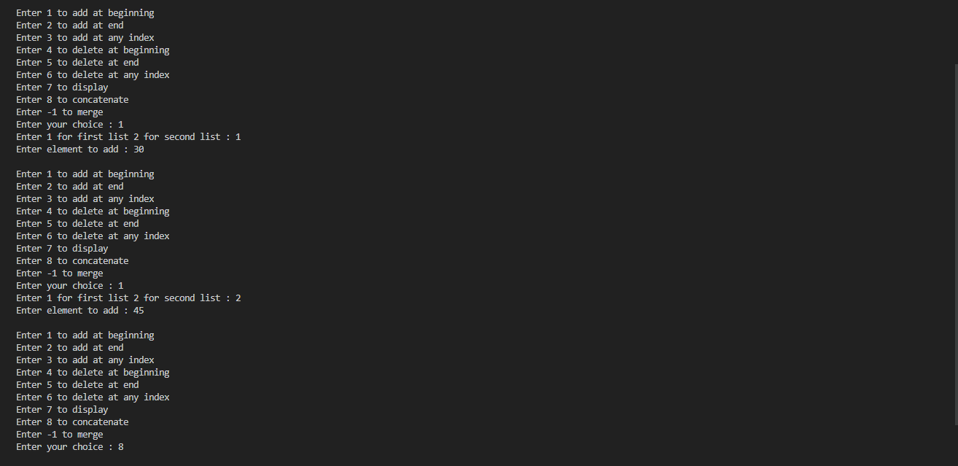

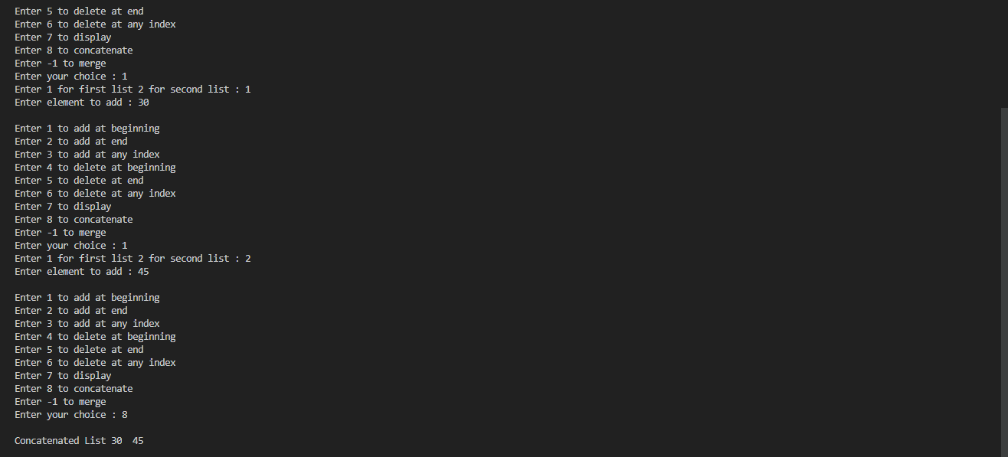

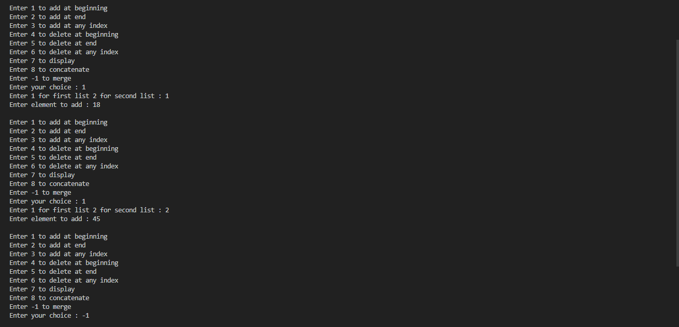



**LAB-8**

**WAP to implement Stack & Queues using Linked Representation.**

**Stack**

#include <stdio.h>

#include <stdlib.h>

typedef struct node{

int data;

struct node *link;

}node;

node *top=NULL;

void push()

{

node *temp;

temp=(node *)malloc(sizeof(node));

printf("Enter node element\n");

scanf("%d",&temp->data);

temp->link=NULL;

if(top==NULL)

{

top=temp;

}

else

{

temp->link=top;

top=temp;

}

}

void pop()

{

node *temp;

if(top==NULL)

{

printf("Stack is empty\n");

}

else

{

temp=top;

top=temp->link;

temp->link=NULL;

free(temp);

}

}

void display()

{

node *temp=top;

if(temp==NULL)

{

printf("Stack is empty\n");

}

else

{

while(temp!=NULL)

{

printf("%d\n",temp->data);

temp=temp->link;

}

}

}

int main()

{

int op,len;

while(1)

{ printf("Enter the operation\n1.Push\n");

printf("2.Pop\n3.Display\n4.Exit\n");

scanf("%d",&op);

switch (op)

{

case 1:push();

break;

case 2: pop();

break;

case 3: display();

break;

case 4: exit(0);

break;

default: printf("No such operation\n");

}

}

return 0;

}

**OUTPUT:**



**Queue:**

#include <stdio.h>

#include <stdlib.h>

typedef struct node{

int data;

struct node *link;

}node;

node *root=NULL;

void enqueue()

{

node *temp;

temp=(node *)malloc(sizeof(node));

printf("Enter the node element\n");

scanf("%d",&temp->data);

temp->link=NULL;

if(root==NULL)

{

root=temp;

}

else

{

node *p=root;

while(p->link!=NULL)

{

p=p->link;

}

p->link=temp;

}

}

void dequeue()

{

node *temp;

if(root==NULL)

{

printf("Queue is empty\n");

}

else

{

temp=root;

root=temp->link;

temp->link=NULL;

free(temp);

}

}

void display()

{

node *temp=root;

if(temp==NULL)

{

printf("Queue is empty\n");

}

else

{

while(temp!=NULL)

{

printf("%d\n",temp->data);

temp=temp->link;

}

}

}

int main()

{

int op,len;

while(1)

{ printf("Enter the operation\n1.Enqueue\n2.Dequeue\n3.Display\n4.Exit\n");

scanf("%d",&op);

switch (op)

{

case 1:enqueue();

break;

case 2: dequeue();

break;

case 3: display();

break;

case 4: exit(0);

break;

default: printf("No such operation\n");

}

}

return 0;

}

**OUTPUT:**





**LAB-9**

**WAP Implement doubly link list with primitive operations**

**a) a) Create a doubly linked list. b) Insert a new node to the left of the node.**

**b) c) Delete the node based on a specific value. c) Display the contents of the list.**

#include <stdio.h>

#include <stdlib.h>

typedef struct Node {

int value;

struct Node* prev;

struct Node* next;

}node;

node* head = NULL;

void add_beg(int value) {

node* ptr = (node*) malloc(sizeof(node));

ptr->value = value;

ptr->prev = NULL;

ptr->next = head;

if(head!=NULL) {

head->prev = ptr;

}

head = ptr;

}

void add_key(int value, int key) {

node* tmp = head;

while(tmp!=NULL) {

if(tmp->value == key) {

break;

}

tmp = tmp->next;

}

if(tmp==NULL) {

printf("\nNo Match\n");

return;

}

if(tmp==head) {

add_beg(value);

return;

}

node* ptr = (node*) malloc(sizeof(node));

ptr->value = value;

ptr->prev = tmp->prev;

ptr->next = tmp;

(tmp->prev)->next = ptr;

tmp->prev = ptr;

}

void del_key(int key) {

if(head == NULL) {

printf("\nList is Empty\n");

return;

}

node* tmp = head;

while(tmp != NULL) {

if(tmp -> value == key) {

break;

}

tmp = tmp->next;

}

if(tmp==head) {

if(head->next==NULL)

{

free(head);

head=NULL;

return;

}

head = head->next;

free(head->prev);

head->prev = NULL;

return;

}

if(tmp==NULL) {

printf("\nNo Match\n");

return;

}

if(tmp->next==NULL) {

tmp->prev->next = NULL;

free(tmp);

return;

}

tmp->next->prev = tmp->prev;

tmp->prev->next = tmp->next;

free(tmp);

}

void display() {

if(head == NULL) {

printf("\nList is Empty\n");

return;

}

node* tmp = head;

printf("\nLinked list contains : ");

while(tmp!= NULL) {

printf("%d ", tmp->value);

tmp = tmp->next;

}

printf("\n");

}

void main() {

int choice, value, key;

while(1) {

printf("Enter 1 to add at beginning\n");

printf("Enter 2 to add at left of a node\n");

printf("Enter 3 to delete a node\n");

printf("Enter 4 to display\n");

printf("Enter -1 to quit\n");

printf("Enter your choice : ");

scanf("%d", &choice);

if(choice==-1)

break;

switch(choice) {

case 1:

printf("\nEnter value to insert : ");

scanf("%d", &value);

add_beg(value);

break;

case 2:

printf("\nEnter value to insert : ");

scanf("%d", &value);

printf("\nEnter value of key node : ");

scanf("%d", &key);

add_key(value, key);

break;

case 3:

printf("\nEnter value of node to be deleted : ");

scanf("%d", &key);

del_key(key);

break;

case 4:

display();

break;

default:

printf("\n\nWrong Input\n\n");

}

}

printf("\n\n-----DONE-----\n\n");

}

**OUTPUT:**





**LAB-10**

**Write a program**

**a) To construct a binary Search tree.**

**b) To traverse the tree using all the methods i.e., in-order, preorder and post order**

**c) To display the elements in the tree.**

#include <stdio.h>

#include <stdlib.h>

struct btnode

{

int value;

struct btnode *l;

struct btnode *r;

}*root = NULL, *temp = NULL, *t2, *t1;

void insert();

void inorder(struct btnode *t);

void create();

void search(struct btnode *t);

void preorder(struct btnode *t);

void postorder(struct btnode *t);

int flag = 1;

void main()

{

int ch;

while(1)

{

printf("\n**MENU**\n");

printf("1 - Insert an element into tree\n");

printf("2 - Inorder Traversal\n");

printf("3 - Preorder Traversal\n");

printf("4 - Postorder Traversal\n");

printf("5 - Exit\n");

printf("\nEnter your choice : ");

scanf("%d", &ch);

switch (ch)

{

case 1:

insert();

break;

case 2:

printf("\nINORDER TRAVERSAL:\n");

inorder(root);

break;

case 3:

printf("\nPREORDER TRAVERSAL:\n");

preorder(root);

break;

case 4:

printf("\nPOSTORDER TRAVERSAL:\n");

postorder(root);

break;

case 5:

exit(0);

default :

printf("Invalid Choice!\n");

break;

}

}

}

void create()

{

int data;

printf("Enter data of node to be inserted : ");

scanf("%d", &data);

temp = (struct btnode*)malloc(1*sizeof(struct btnode));

temp->value = data;

temp->l = temp->r = NULL;

}

void insert()

{

create();

if (root == NULL)

root = temp;

else

search(root);

}

void search(struct btnode *t)

{

if ((temp->value > t->value) && (t->r != NULL))

search(t->r);

else if ((temp->value > t->value) && (t->r == NULL))

t->r = temp;

else if ((temp->value < t->value) && (t->l != NULL))

search(t->l);

else if ((temp->value < t->value) && (t->l == NULL))

t->l = temp;

}

void inorder(struct btnode *t)

{

if (root == NULL)

{

printf("No elements in the tree!\n");

return;

}

if (t->l != NULL)

inorder(t->l);

printf("%d -> ", t->value);

if (t->r != NULL)

inorder(t->r);

}

void preorder(struct btnode *t)

{

if (root == NULL)

{

printf("No elements in the tree!\n");

return;

}

printf("%d -> ", t->value);

if (t->l != NULL)

preorder(t->l);

if (t->r != NULL)

preorder(t->r);

}

void postorder(struct btnode *t)

{

if (root == NULL)

{

printf("No elements in the tree!\n");

return;

}

if (t->l != NULL)

postorder(t->l);

if (t->r != NULL)

postorder(t->r);

printf("%d -> ", t->value);

}

**OUTPUT:**

